Jars AI Assessment: Animation Navigator

Overview
Your task is to implement an Animation Navigator interface in Unity based on the provided Figma design. This tool allows users to browse and preview character animations.

Time Expectation
- Total time: 2-3 hours maximum (1 hour baseline implementation, 1-2 hours for polish)

Provided Materials
- Figma UI design - link here
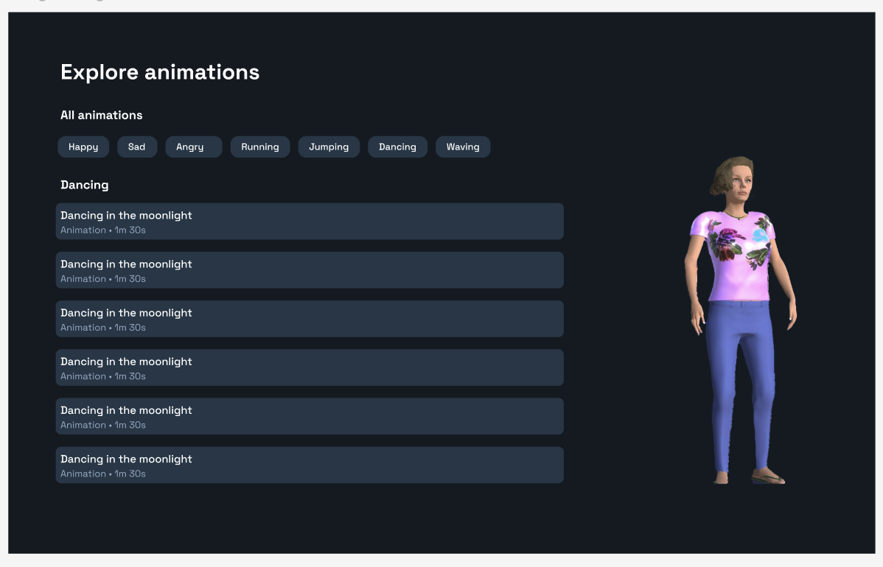
- In the Assets Folder:
  - 6 pre-selected Mixamo animations (with character asset attached)

Requirements

Baseline Requirements (Must Complete)
- Create a UI matching the provided Figma design
- Implement animation category selection (tabs at top)
- Display the list of animations under the selected category
- Allow users to select animations from the list
- Show the selected animation playing on the character model
- Implement proper highlighting for selected category and animation

Core Technical Evaluation Points
- Animation transitions - Smooth blending between animations when switching
- UI responsiveness - Ensure the interface responds immediately to user input
- State management - Maintain proper selected states for buttons and lists
- Code organization - Structure your project with clean, modular code

Design Polish Ideas (Use some, all, none)
- Visual feedback - Add subtle animations for button hovers and selections
- Animation preview controls - Implement play/pause/restart functionality
- Loading states - Incorporate loading indicators
- Responsive layout - Ensure the interface scales appropriately for different resolutions
- Animation speed control
- Simple text search by name functionality
- Animation thumbnails or previews in the list
- Camera controls to view the character from different angles

Evaluation Criteria
We'll assess your submission on:
- Baseline functionality - Does it work as expected?
- Technical implementation - Is the code well-structured and efficient?
- Animation quality - Are transitions smooth and natural?
- Visual polish - Does it match or enhance the design?
- UX considerations - Is the interface intuitive and responsive?
- Creative touches - What unique improvements did you add?

Submission Instructions
- Submit a Unity 6 project via Github and a short (30-60 second) video showing your interface in action
- Include a README.md with:
  - Brief description of your implementation
  - Any design decisions or enhancements you made
  - What you would improve with more time
We're looking for candidates who can create solutions that are both technically sound and feel good to use. Best of luck!

